**Project 1 : California Housing Price Prediction**

* Code Snippet followed a Screenshot of the output

Q1. Load the data and print first few rows of this data

# Step1: Load the data

# Step1.1: Read the “housing. xlsx'” file from the folder into the program

housingData =pd.read_excel (r'housing.xlsx')

# Step2.2: Print first few rows of this data

housingData.head()

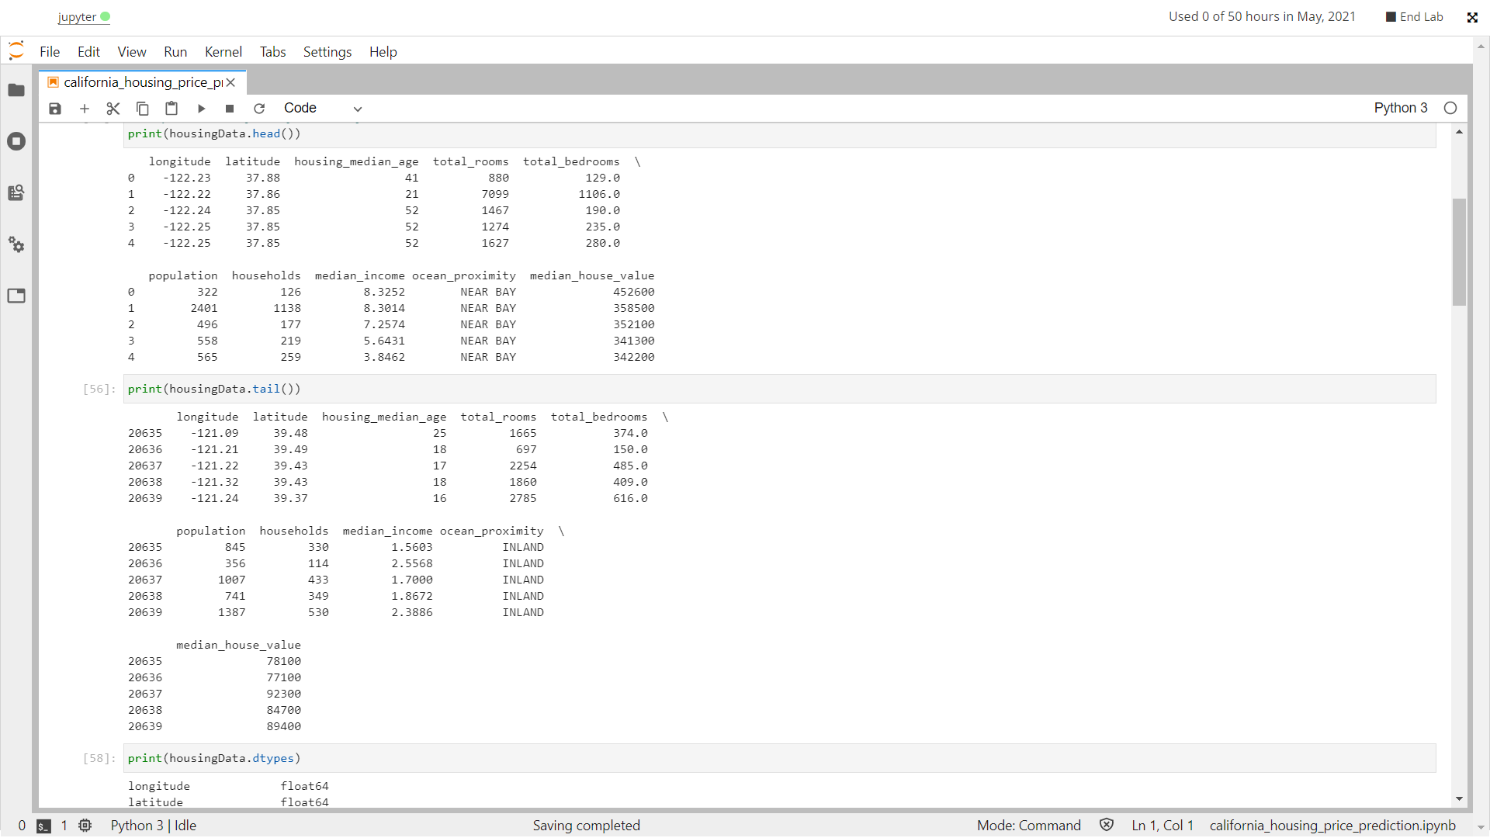

Q2. Separate features and labels, deal with missing value, Encode categorical data, Split the dataset into training and testing set, standardized the data

# Step2.3: Extract input (X) and output (y) data from the dataset

X = housingData.iloc[:, :-1].values

y = housingData.iloc[:, [-1]].values

# Step3: Handle missing values:

# Fill the missing values with the mean of the respective column

from sklearn.impute import SimpleImputer

missingValueImputer = SimpleImputer(missing_values=np.nan, strategy='mean')

X[:, :-1] = missingValueImputer.fit_transform(X[:, :-1])

y = missingValueImputer.fit_transform(y)

# Step4: Encode categorical data:

# Convert categorical column in the dataset to numerical data

from sklearn.preprocessing import LabelEncoder

X_labelencoder = LabelEncoder()

X[:, -1] = X_labelencoder.fit_transform(X[:, -1])

# Step5: Split the dataset: Split the data into

# 80% training dataset and 20% test dataset

from sklearn.model_selection import train_test_split

X_train, X_test, y_train, y_test = train_test_split(X, y, test_size = 0.2, random_state = 0)

# Step6: Standardize data: Standardize training and test datasets from sklearn.preprocessing import StandardScaler

scaler = StandardScaler() X_train = scaler.fit_transform(X_train)

X_test = scaler.transform(X_test)

y_train = scaler.fit_transform(y_train)

y_test = scaler.transform(y_test)

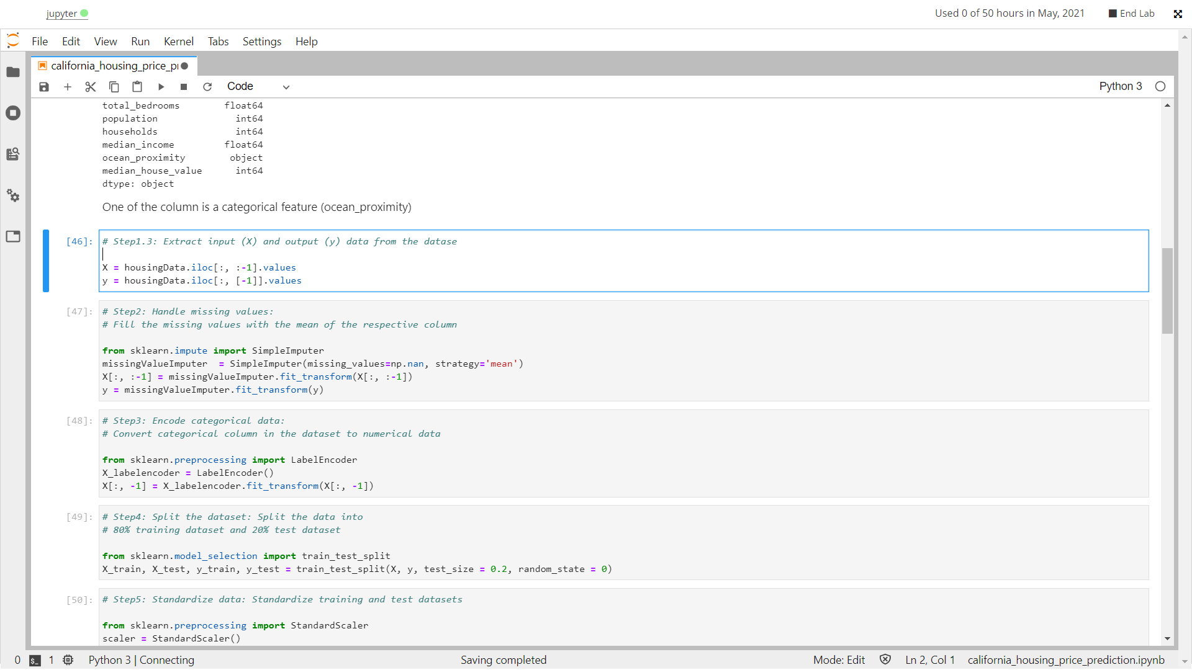

Q3. Task1: Perform Linear Regression

# Task1.1: Perform Linear Regression on training data from sklearn.linear_model import LinearRegression

linearRegression = LinearRegression()

linearRegression.fit(X_train, y_train)

# Task1.2: Predict output for test dataset using the fitted model predictionLinear = linearRegression.predict(X_test)

# Task1.3: Print root mean squared error (RMSE) from Linear Regression from sklearn.metrics

import mean_squared_error mseLinear = mean_squared_error(y_test, predictionLinear)

print('Root mean squared error (RMSE) from Linear Regression = ') print(mseLinear)

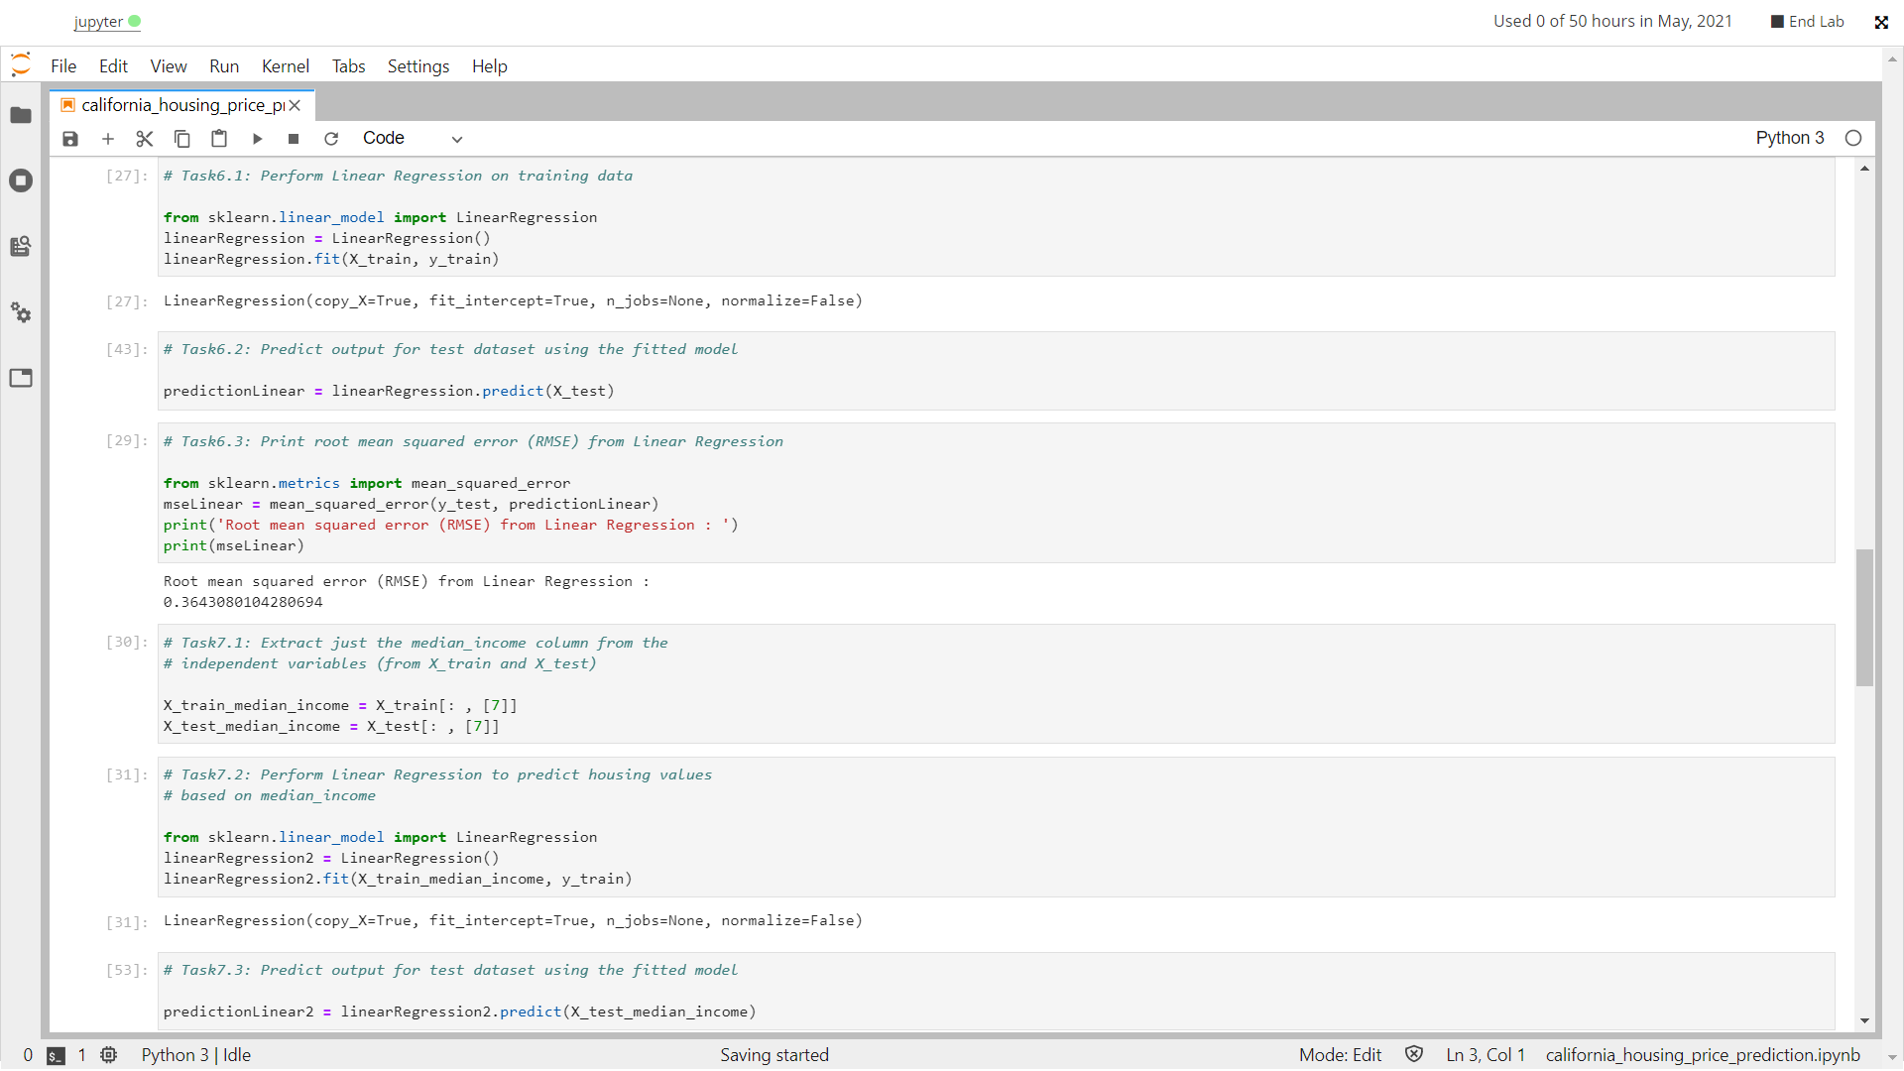

Bonus exercise: Perform Linear Regression with one independent variable

# Task: Extract just the median_income column from the independent

# variables (from X_train and X_test)

X_train_median_income = X_train[: , [7]]

X_test_median_income = X_test[: , [7]]

# Task: Perform Linear Regression to predict housing values

# based on median_income

from sklearn.linear_model import LinearRegression

linearRegression2 = LinearRegression() linearRegression2.fit(X_train_median_income, y_train)

# Task: Predict output for test dataset using the fitted model

predictionLinear2 = linearRegression2.predict(X_test_median_income)

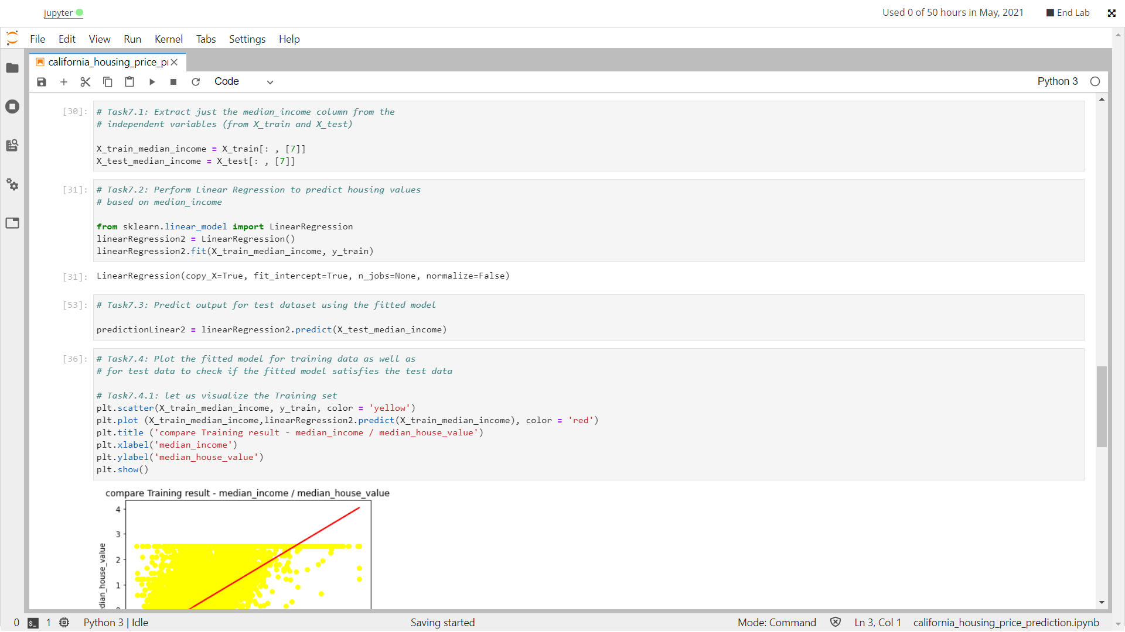

# Task: Plot the fitted model for training data as well as

# for test data to check if the fitted model satisfies the test data

# Task: let us visualize the Training set

plt.scatter(X_train_median_income, y_train, color = yellow)

plt.plot (X_train_median_income, linearRegression2.predict(X_train_median_income), color = 'red')

plt.title ('compare Training result - median_income / median_house_value') plt.xlabel('median_income')

plt.ylabel('median_house_value')

plt.show()

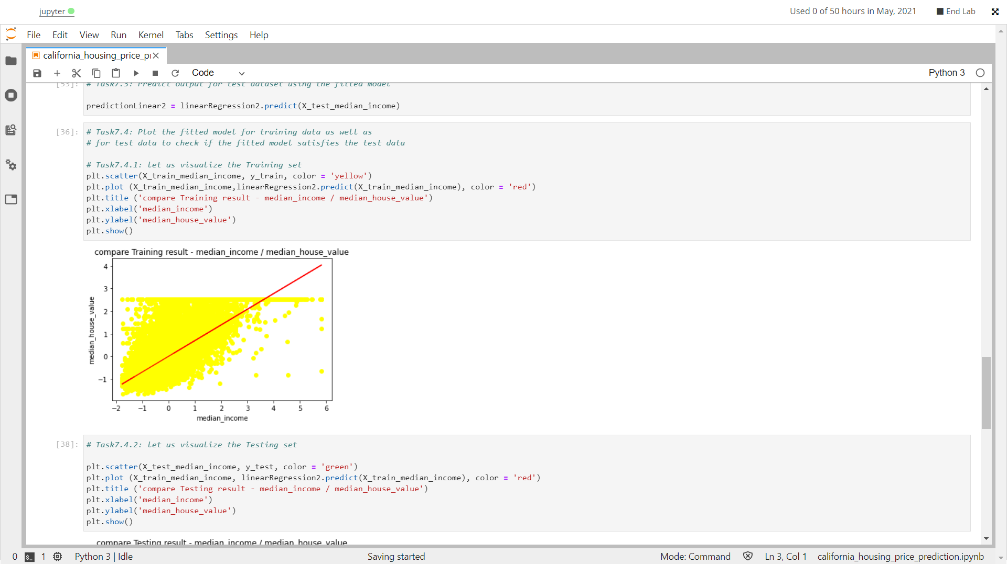

# Task: let us visualize the Testing set

plt.scatter(X_test_median_income, y_test, color = green)

plt.plot (X_train_median_income, linearRegression2.predict(X_train_median_income), color = 'red')

plt.title ('compare Testing result - median_income / median_house_value') plt.xlabel('median_income')

plt.ylabel('median_house_value')

plt.show()

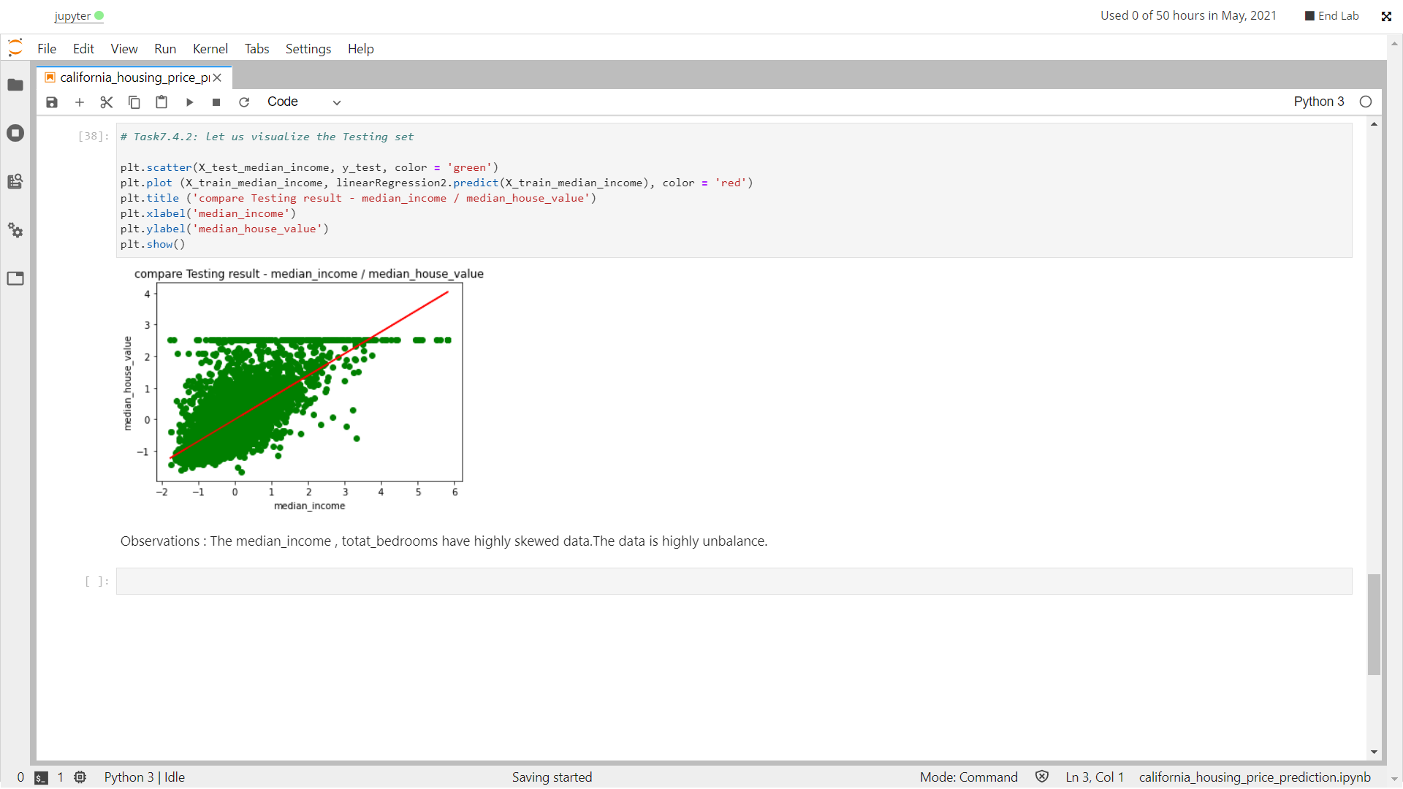

**Observations** : The median_income , totat_bedrooms have highly skewed data.The data is highly unbalance.

------------------------------------END----------------------------